**DAILY ONLINE ACTIVITIES SUMMARY**

|  |  |  |  |  |  |  |  |
| --- | --- | --- | --- | --- | --- | --- | --- |
| **Date:** | | **9/6/2020** | | | | | |
| **Name of the Faculty** | | **REENA LOBO** | | | | | |
| **No. of Students Allotted for monitoring** | | | | | **19** | | |
| **Progress** | | | | | **GOOD** | | |
| **Whether collected report from all the allotted students** | | | | | **18,not submitted-ramitha** | | |
| **Online Test Summary** | | | | | | | |
| **Subject** |  | | | | | | |
| **Semester** |  | | | **Duration** | |  | |
| **No. of students Taken** | | |  | **Passing %** | |  | |
| **Certification Course Summary** | | | | | | | |
| **Course** | | Name of The Course: 1.attended **Fdp on applied ML using python**  Certificate provider:NMAMIT  DURATION:2HRS  2.Atteded webinar on python programing and its applications  Certification provider:pantech  Duration:1hr | | | | | |
| **Certificate Provider** | |  | | | **Duration** | |  |
| **Coding Challenges** | | | | | | | |
| |  | | --- | | **Problem statement.** **Write a Java Program to remove all white spaces from a string without using replace()**  **.Language used for solving: JAVA**  **Whether posted in Github: YES**  **Link:** <https://github.com/orgs/alvas-education-foundation/teams/3rd-year/discussions/73> | | | | | | | | |
| **Status: COMPLETED** | | | | | | | |
| **Uploaded the report in Github** | | | | | **yes** | | |
| **If yes Repository name** | | | | | <https://github.com/reenalobo/ONLINE-ACTIVITY-REPORT/upload/master> | | |
| **Uploaded the report in slack** | | | | | **yes** | | |

Certification Course Details: (Attach the snapshot and briefly write the report for the same)

**Fdp on applied ML using python**

NITTE COLLEGE

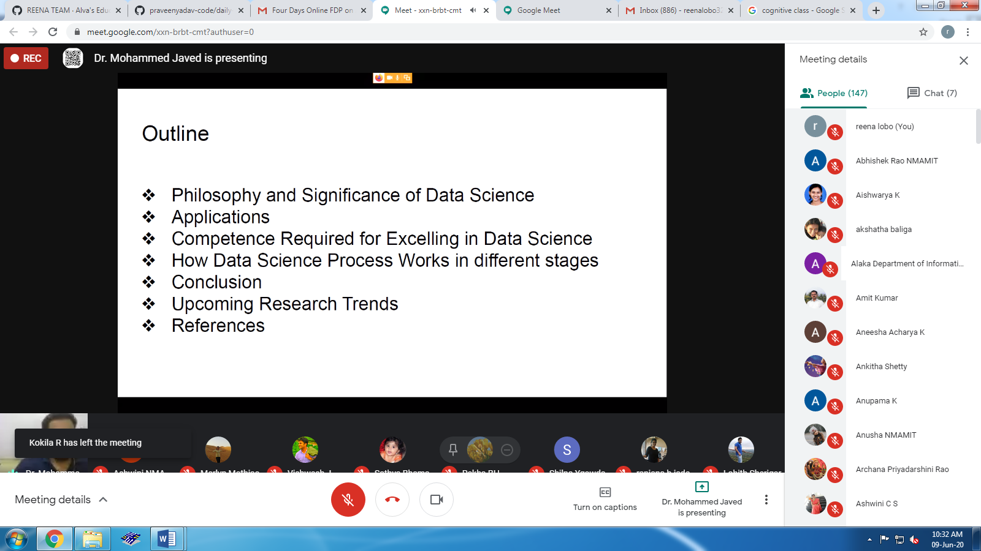

**Completed python for data science course:**

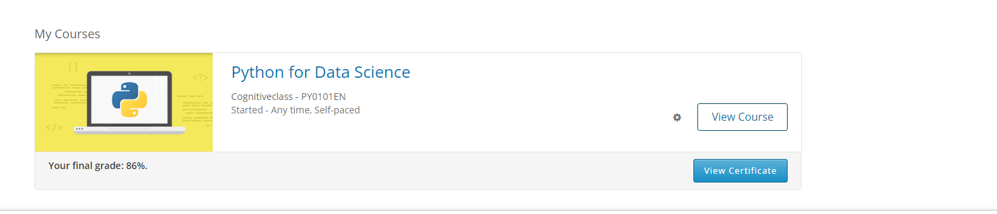

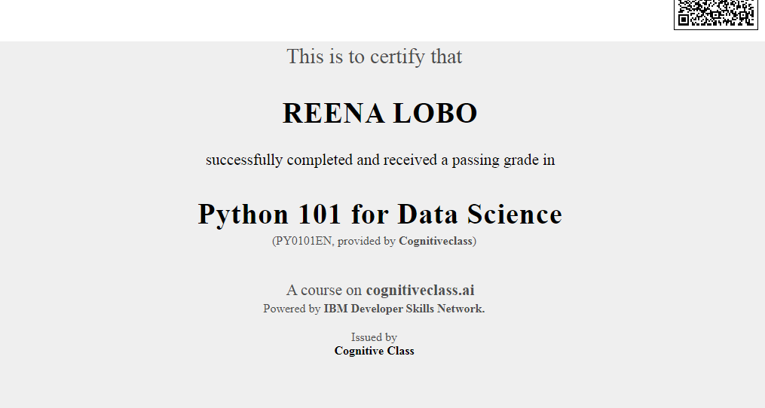

**Coding challenge:**

**Write a Java Program to remove all white spaces from a string without using replace()**

<https://github.com/orgs/alvas-education-foundation/teams/3rd-year/discussions/73>

**attended webinar on python programming and its apllications**

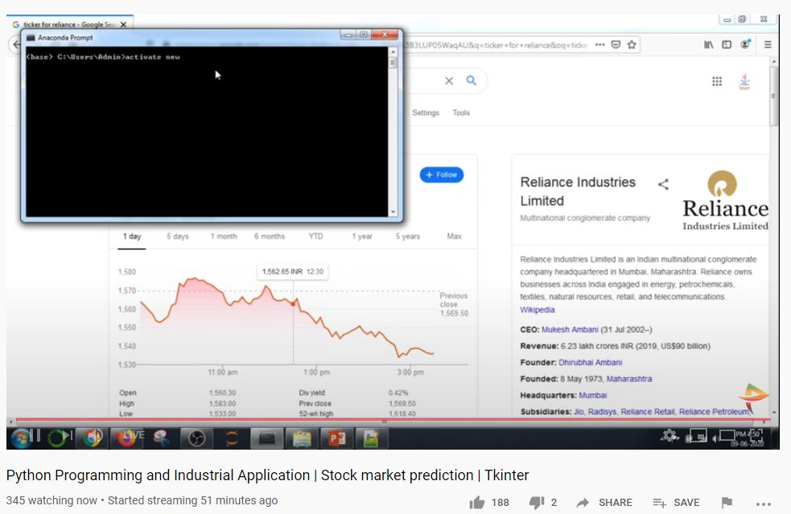

**Students report:**

**Ravali:**

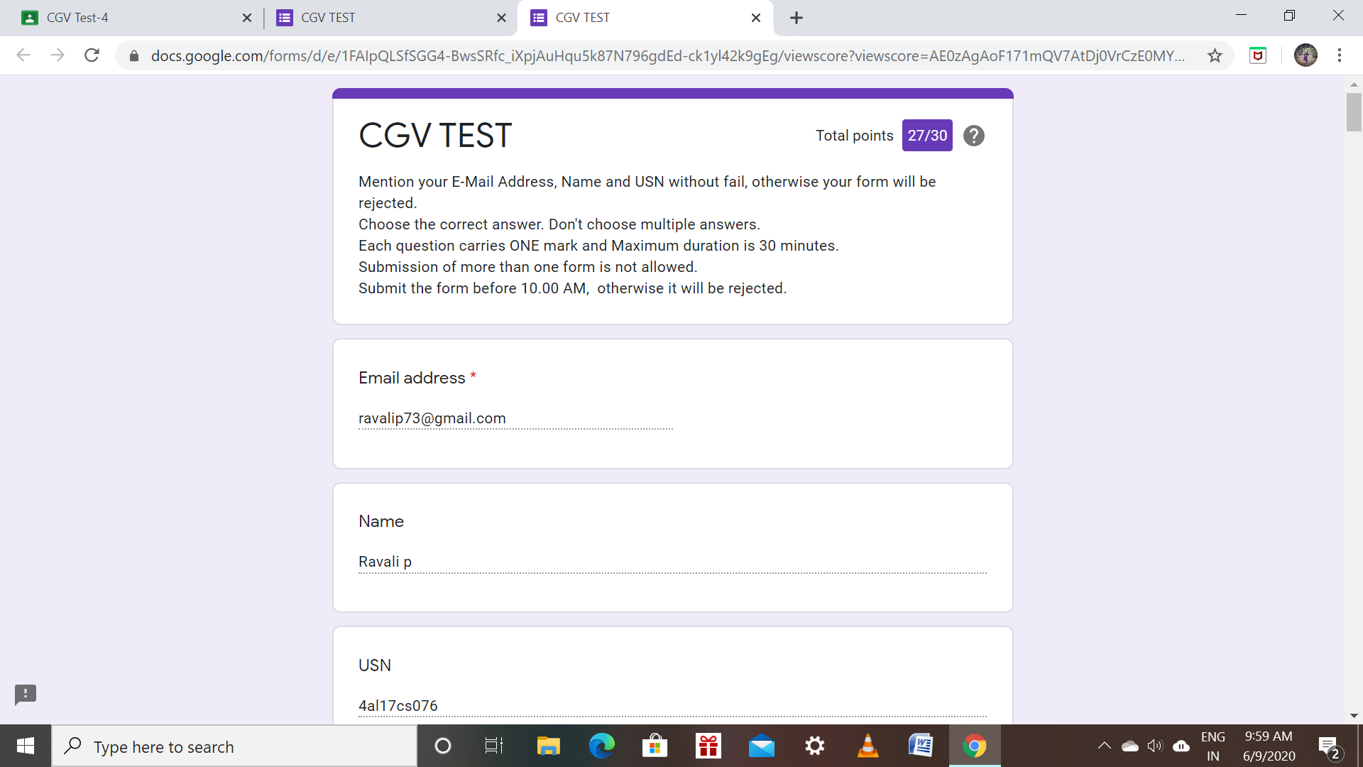

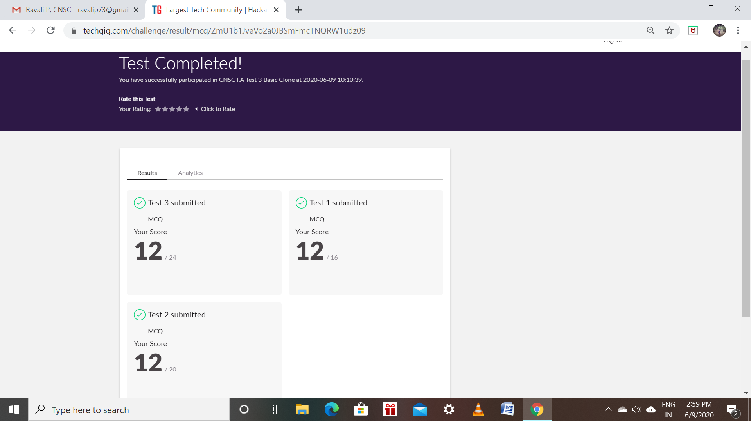

**Raksha:**

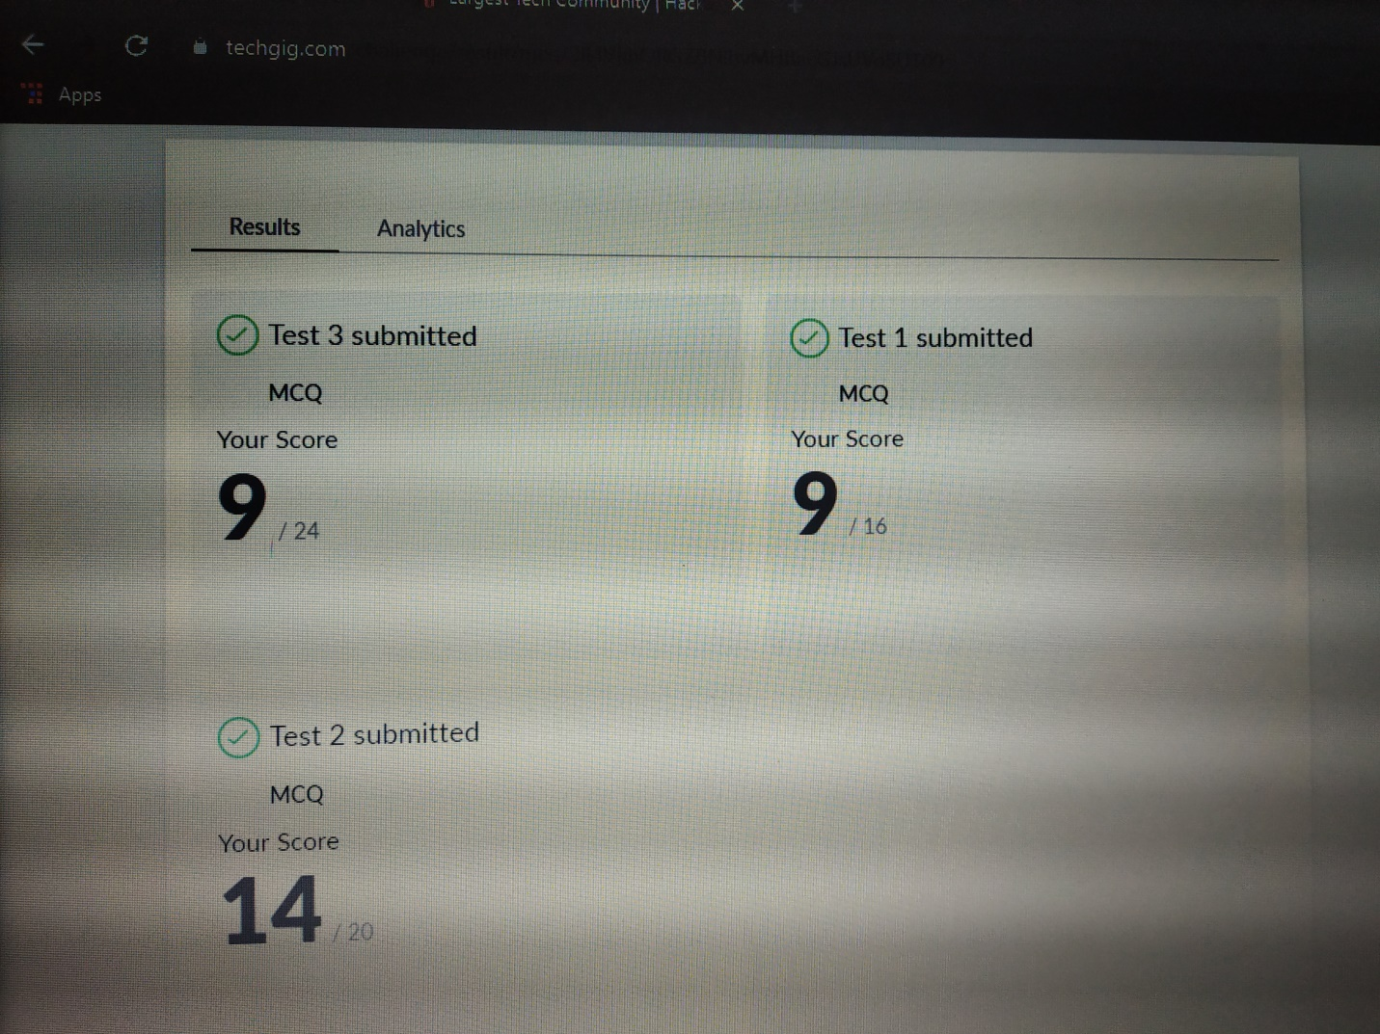

Scored 32 out of 60 in CNSC Test

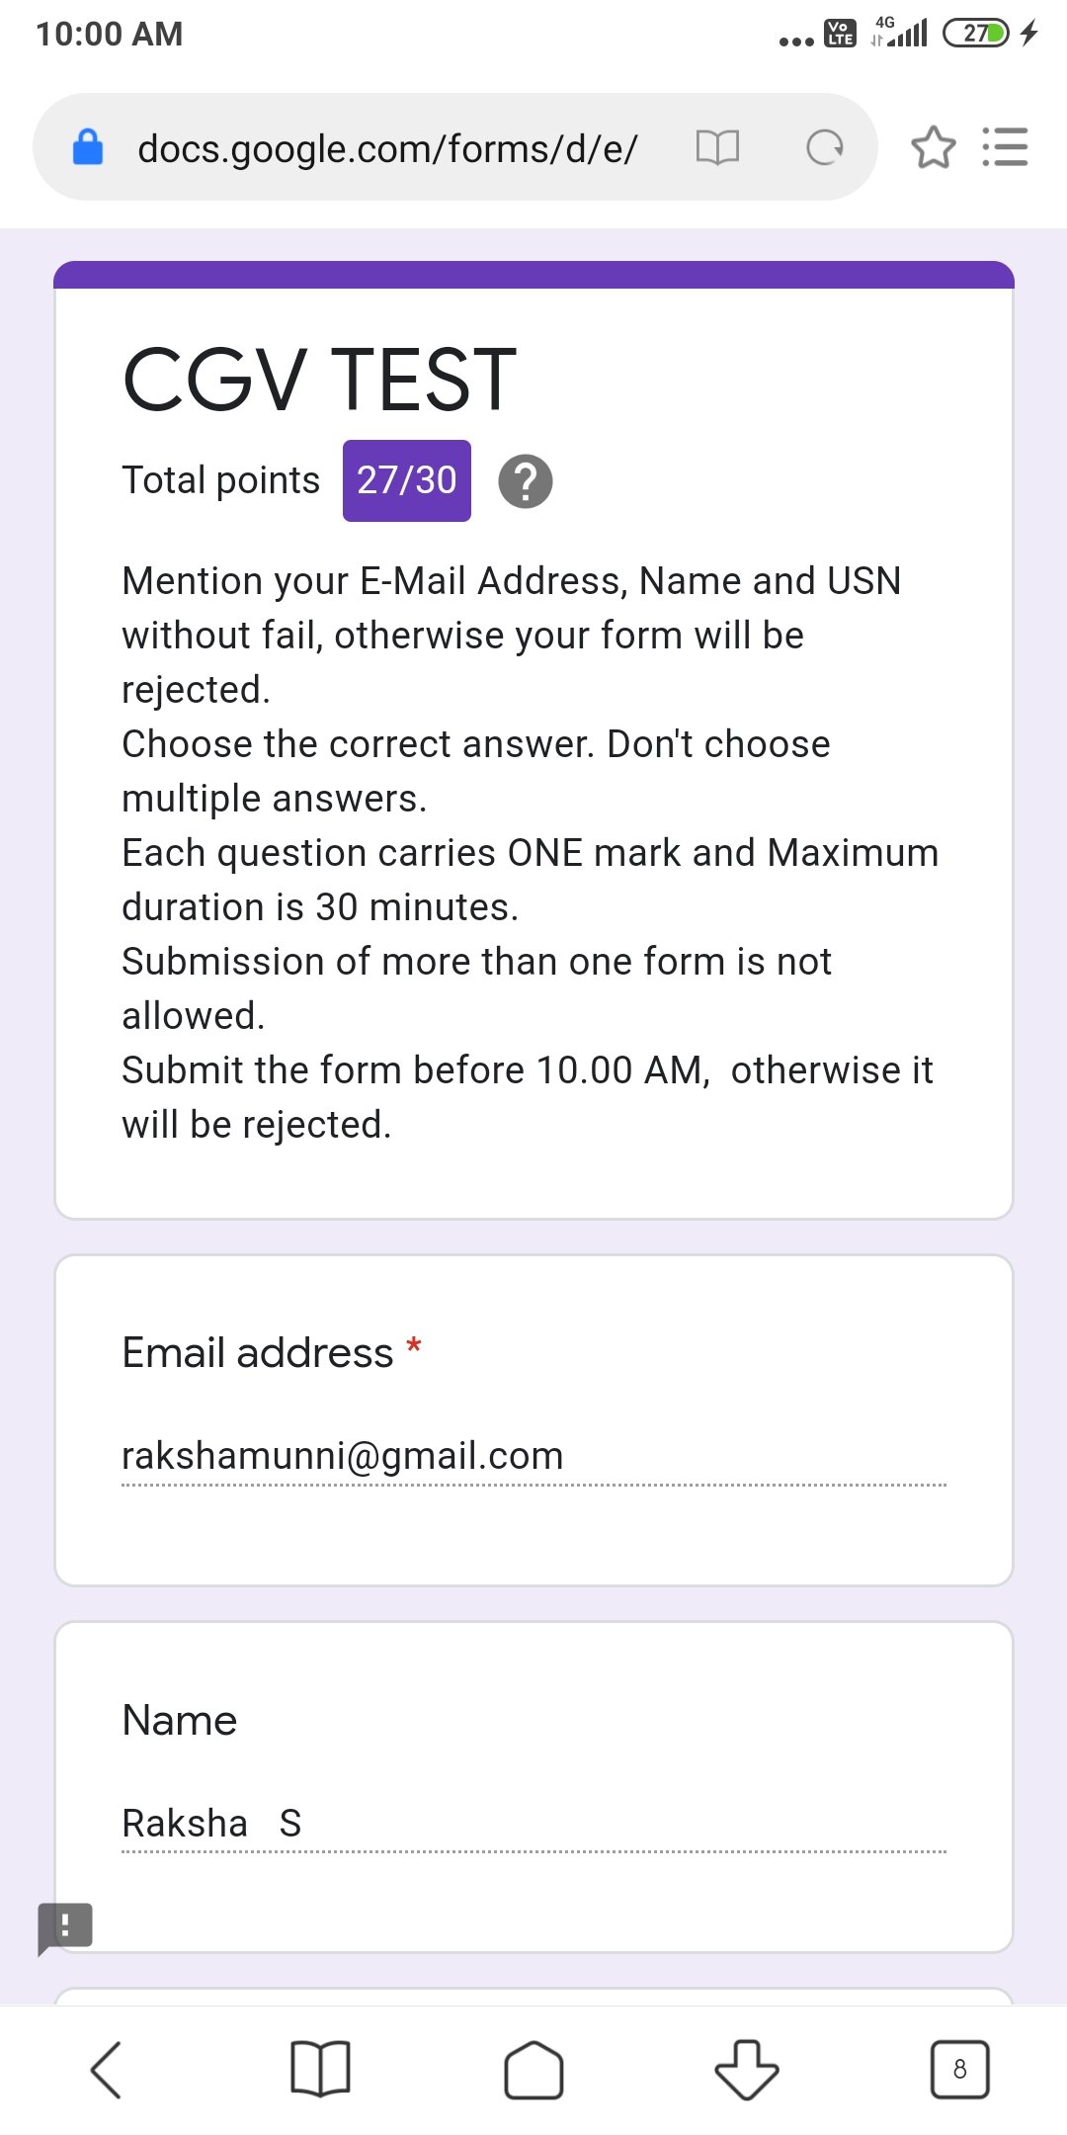

Scored 27 of 30 in CGV Test

**Rohan mahaveer:**

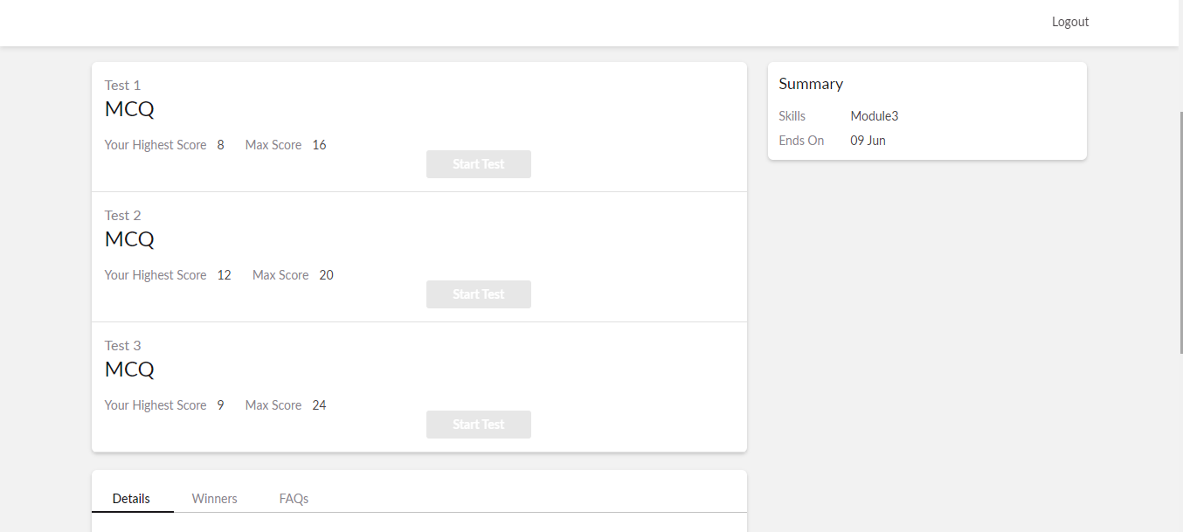

**Preethi:**

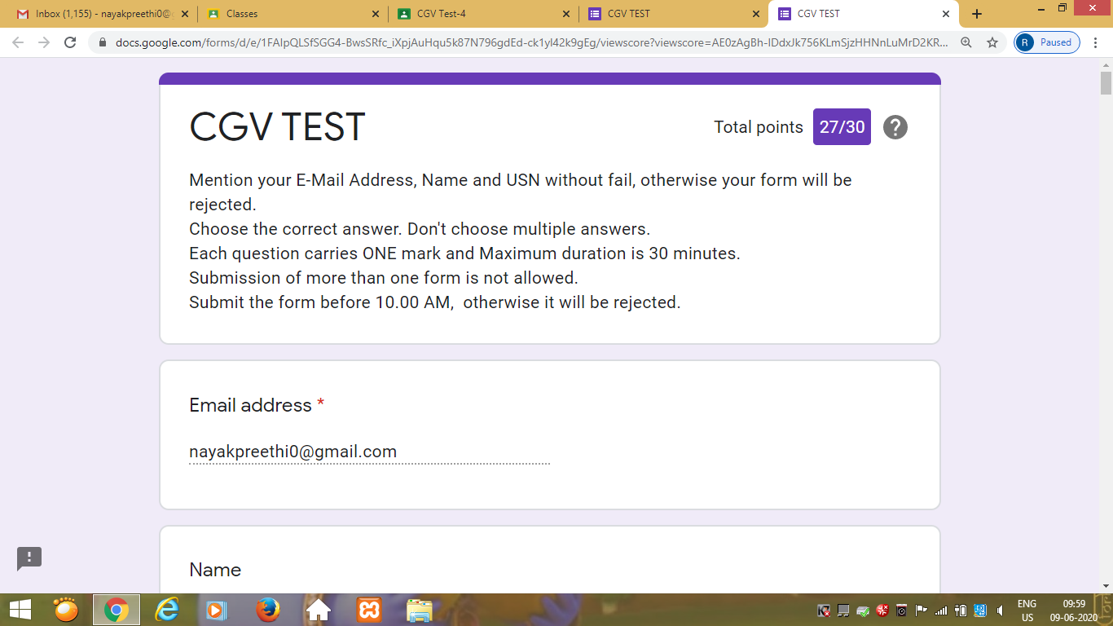

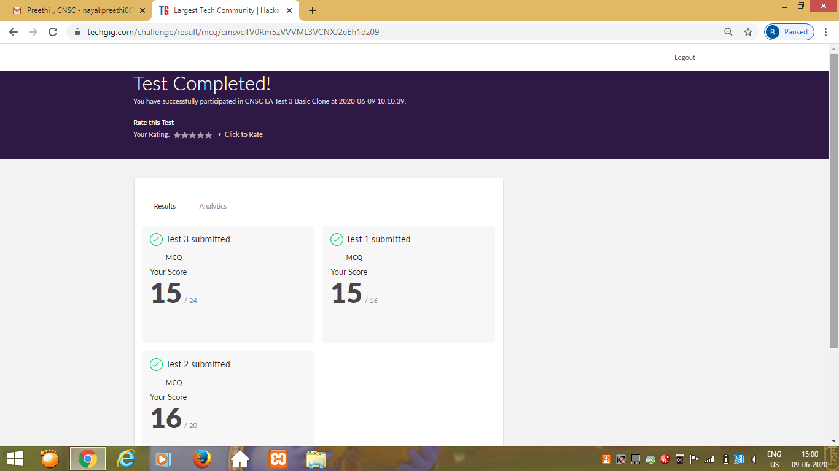

**Rachana:**

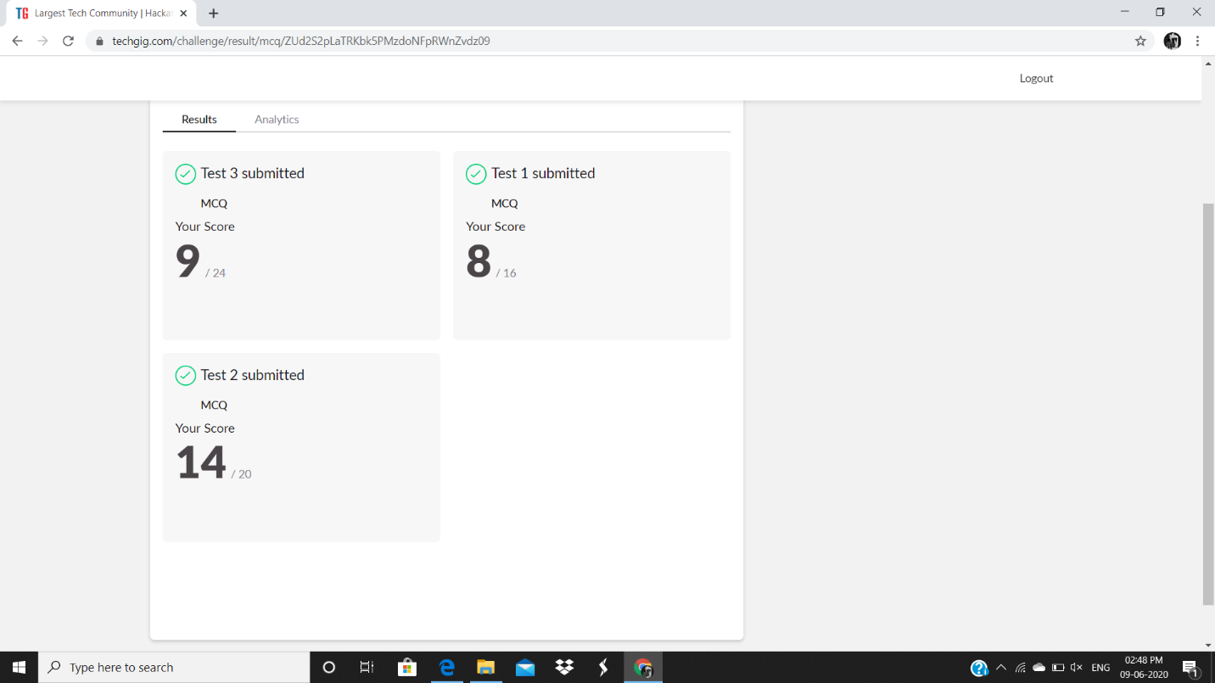

**CGV:**

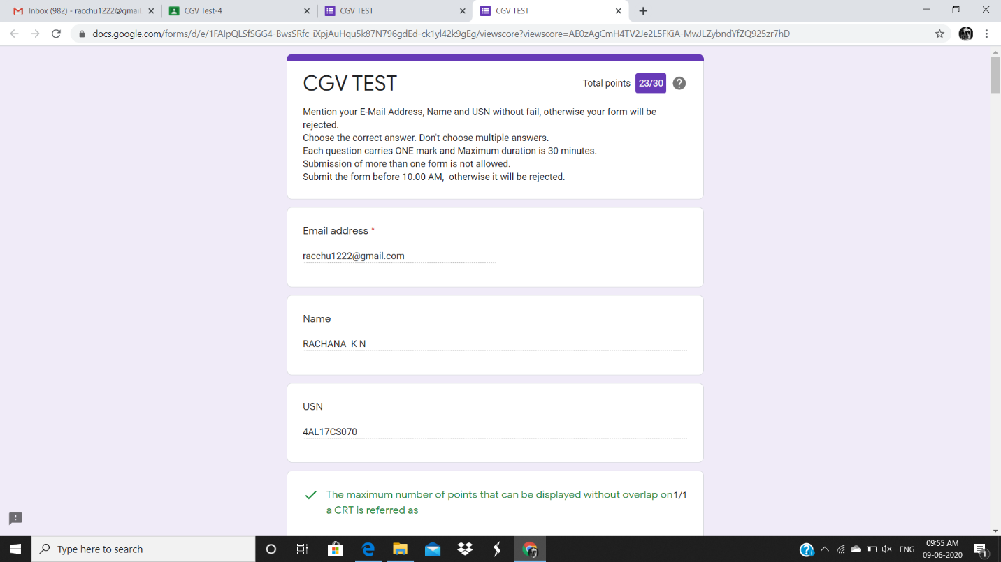

**Priyanka:**

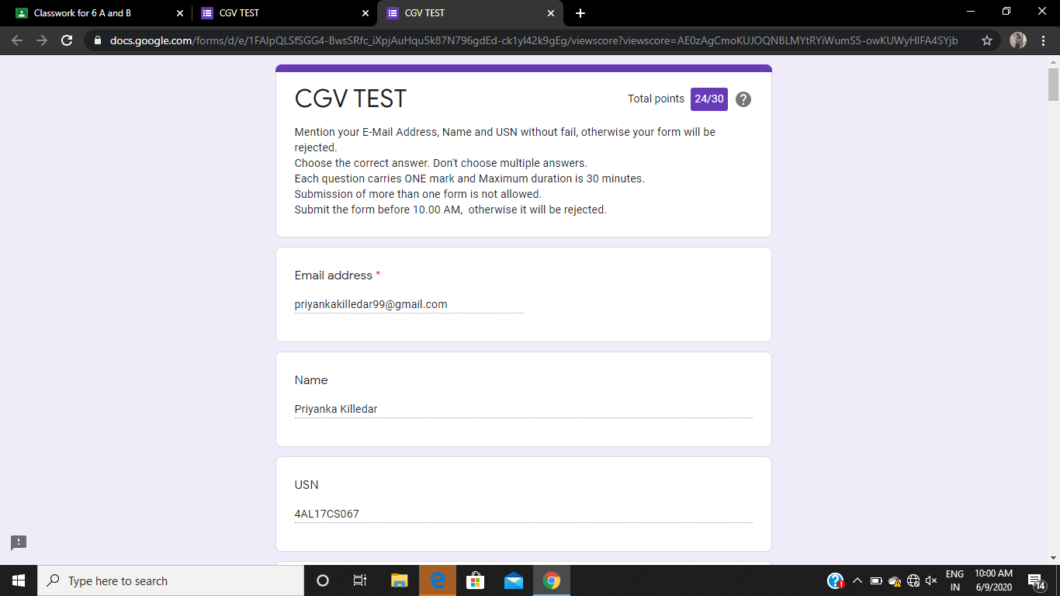

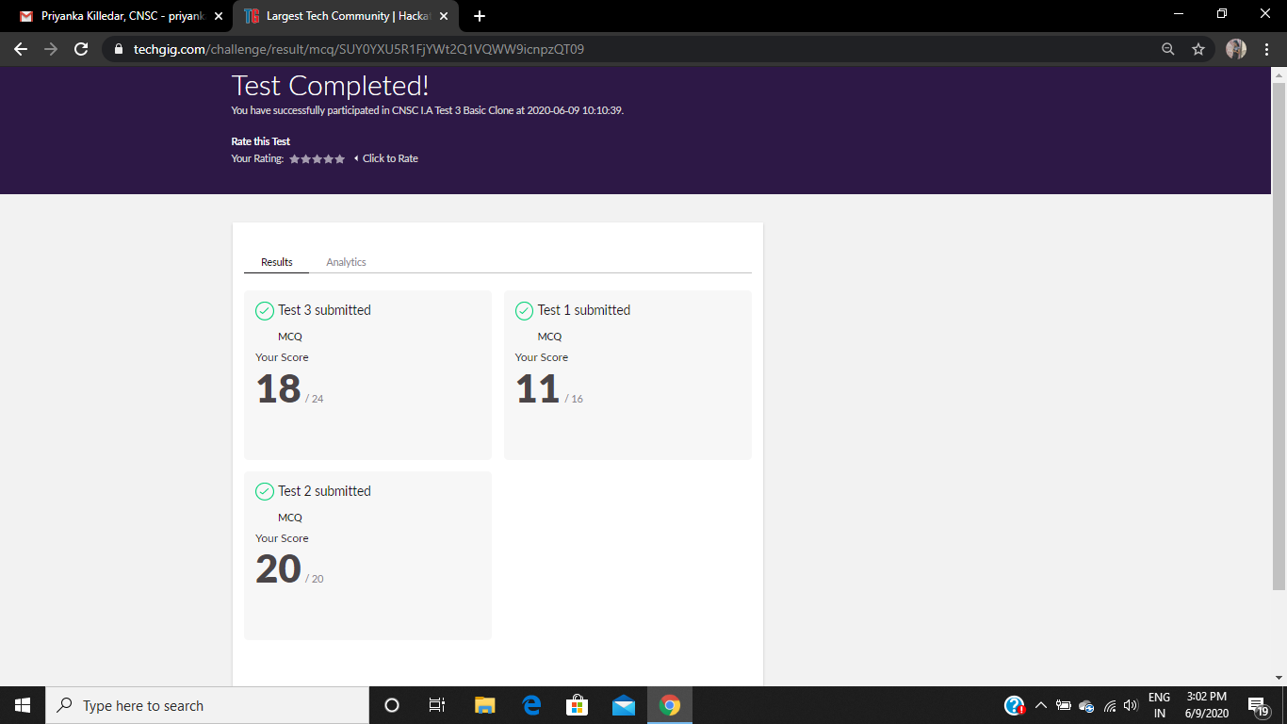

**Certification Course Details:**

**E-Box Classes:**

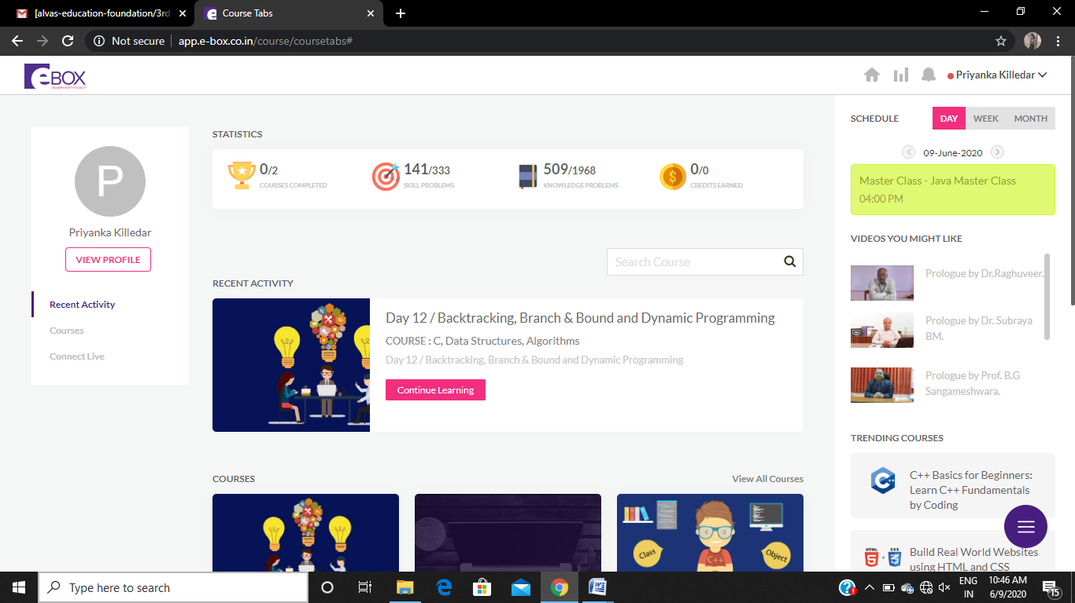

**Sana:**

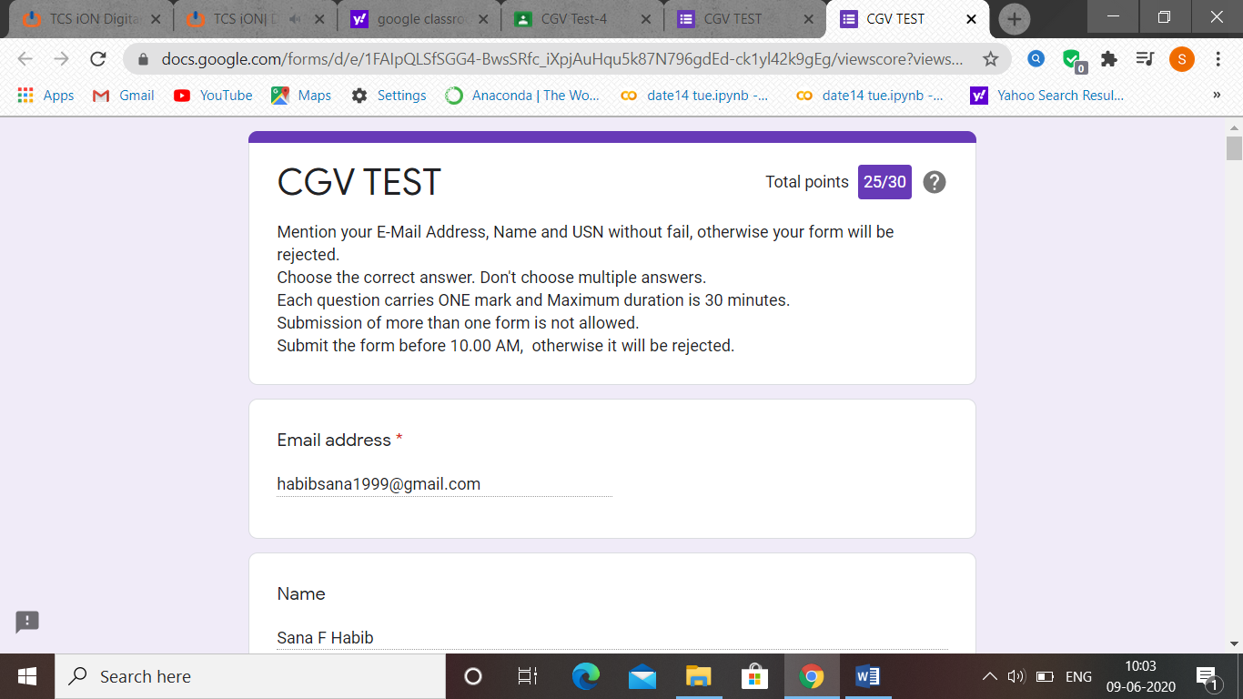

CGV IA test was held today. i.e 9 June 2020. Out of 30 marks I scored 25

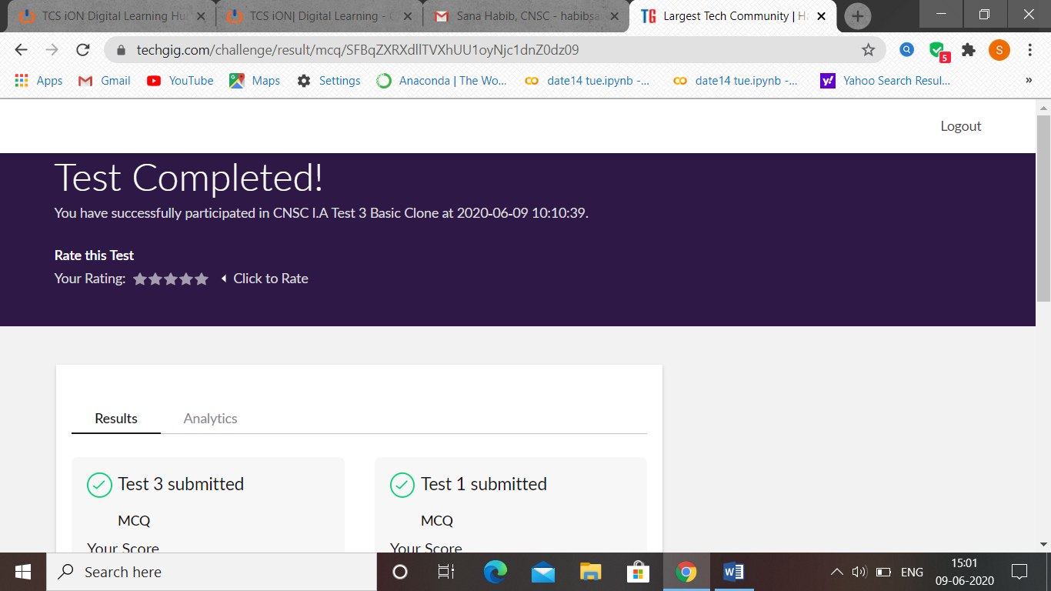

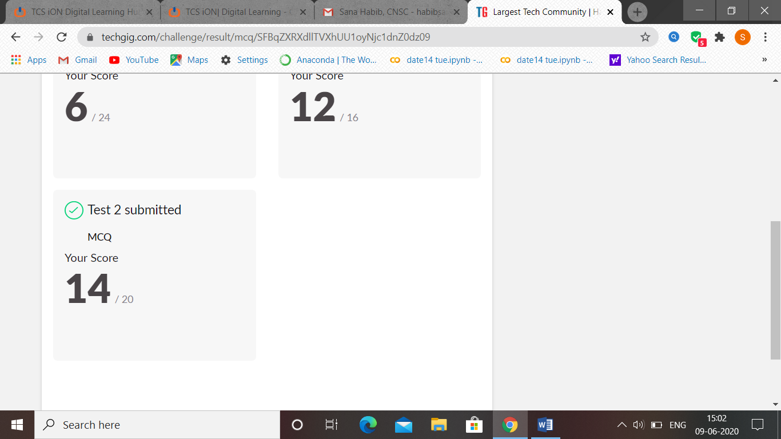

**Atish:**

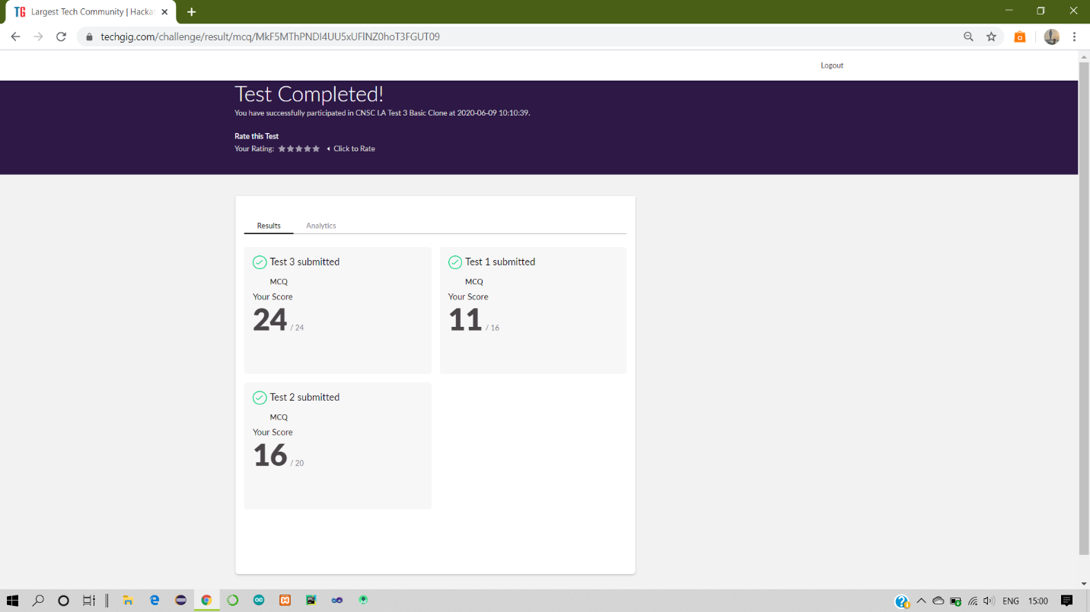

Certification Course Details:

Report-

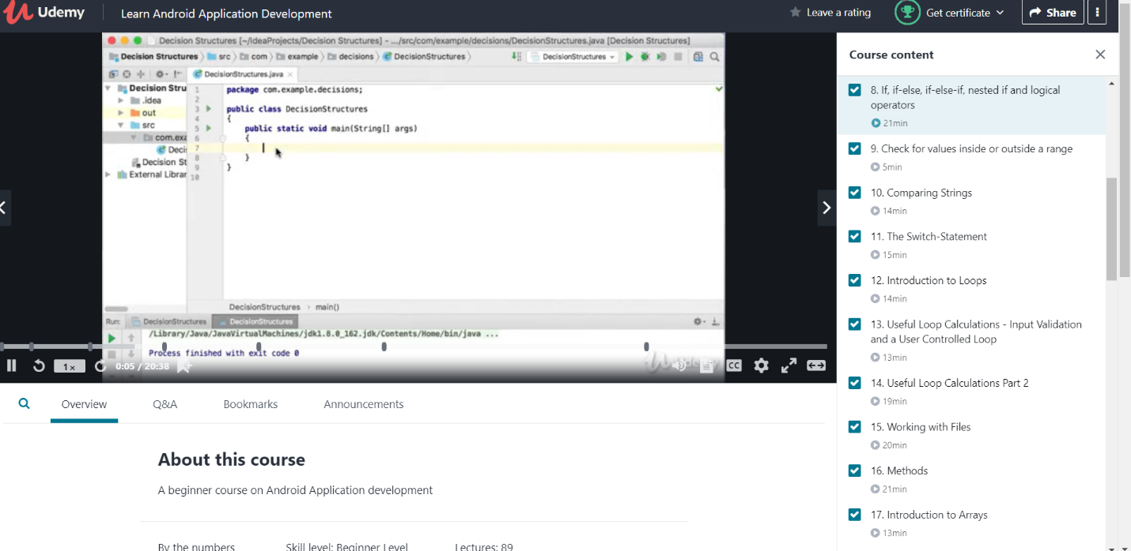

**Dhruvil:**

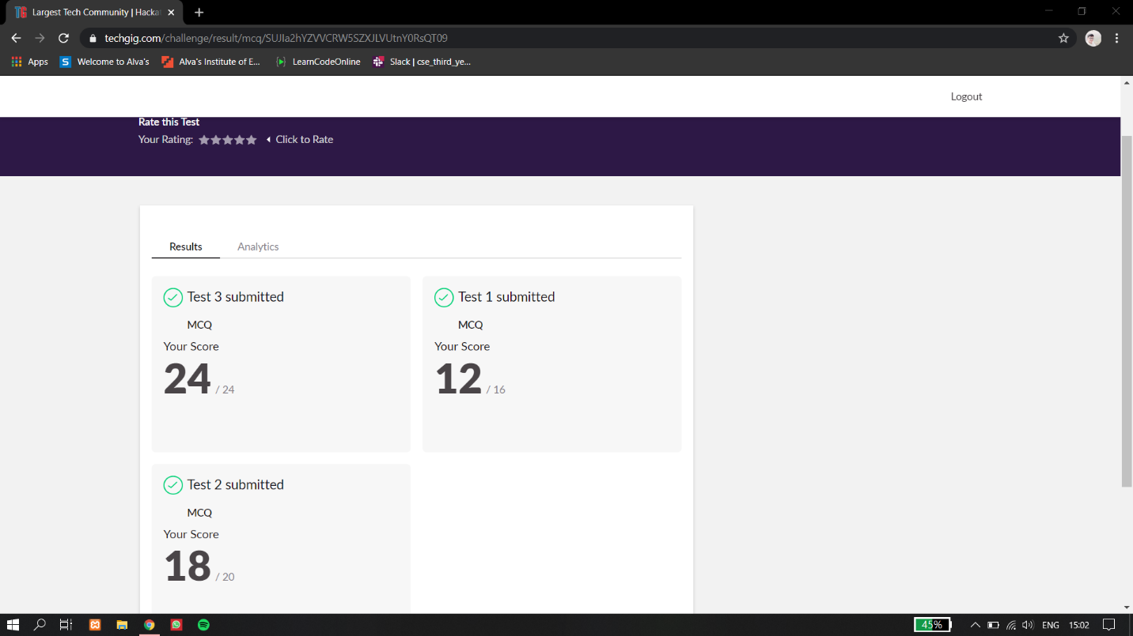

CGV IA-4

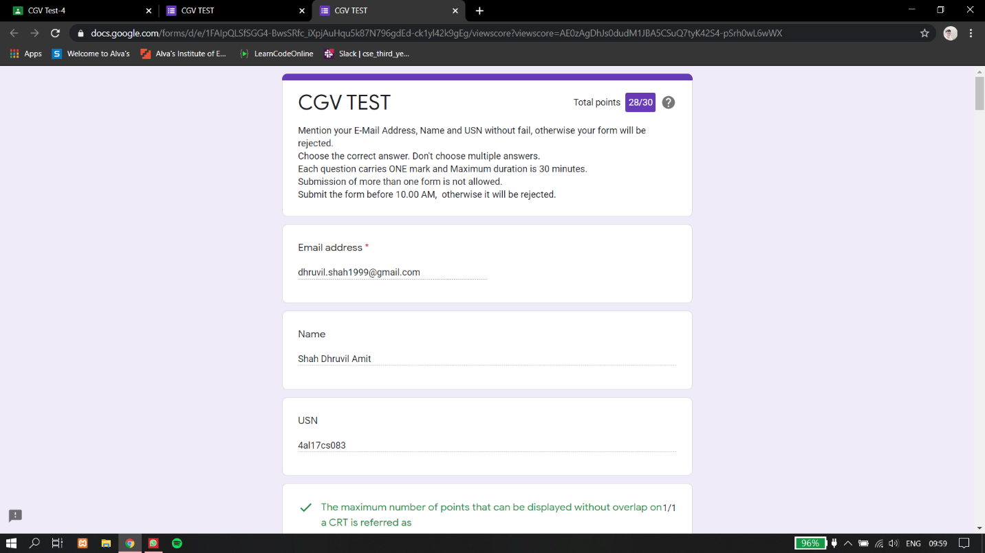

**Rani:**

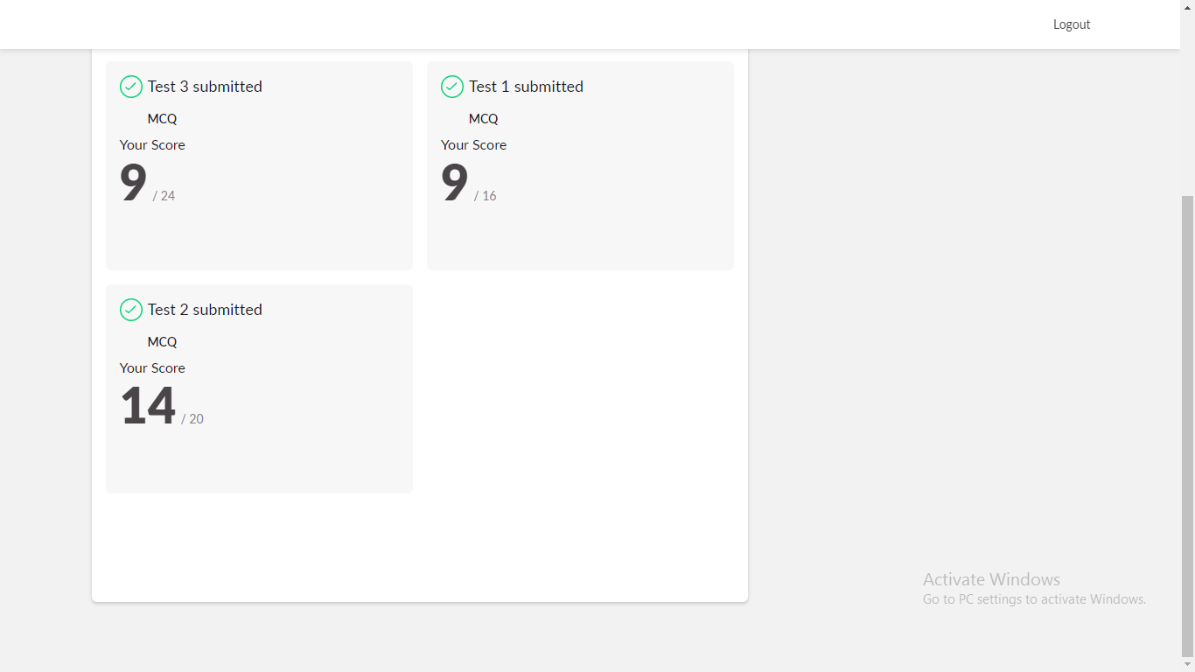

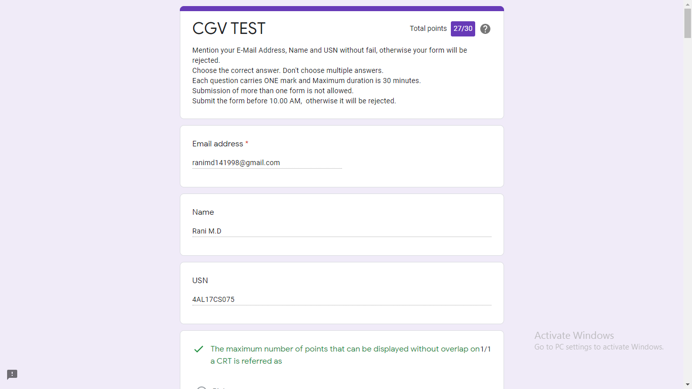

Certification Course Details: (Attach the snapshot and briefly write the

**Priya h t:**

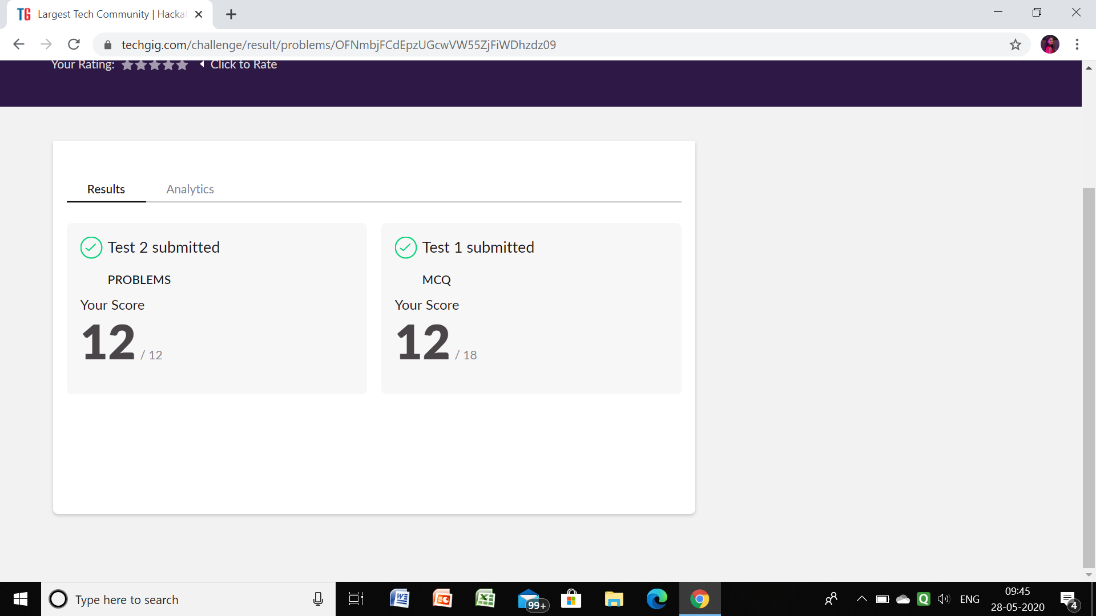

**Certification Course Details:**

Github link for information: <https://github.com/priya3028/Daily-status>

**Topics completed today:**

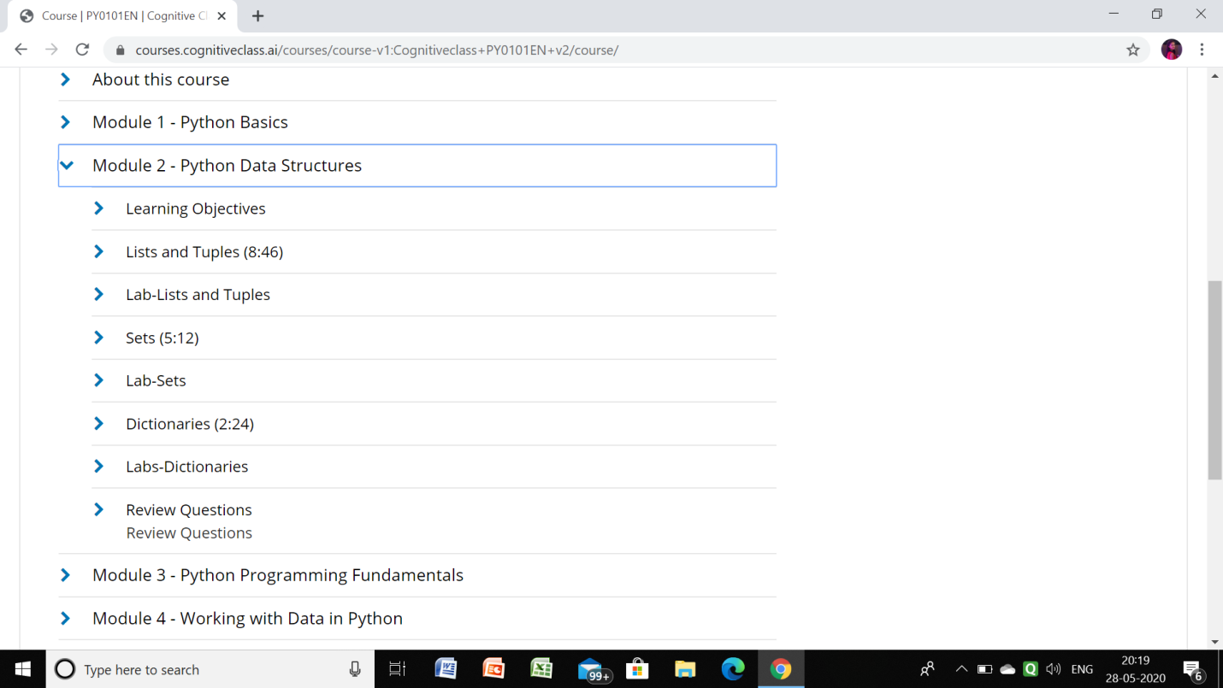

**Rohan vasisata:**

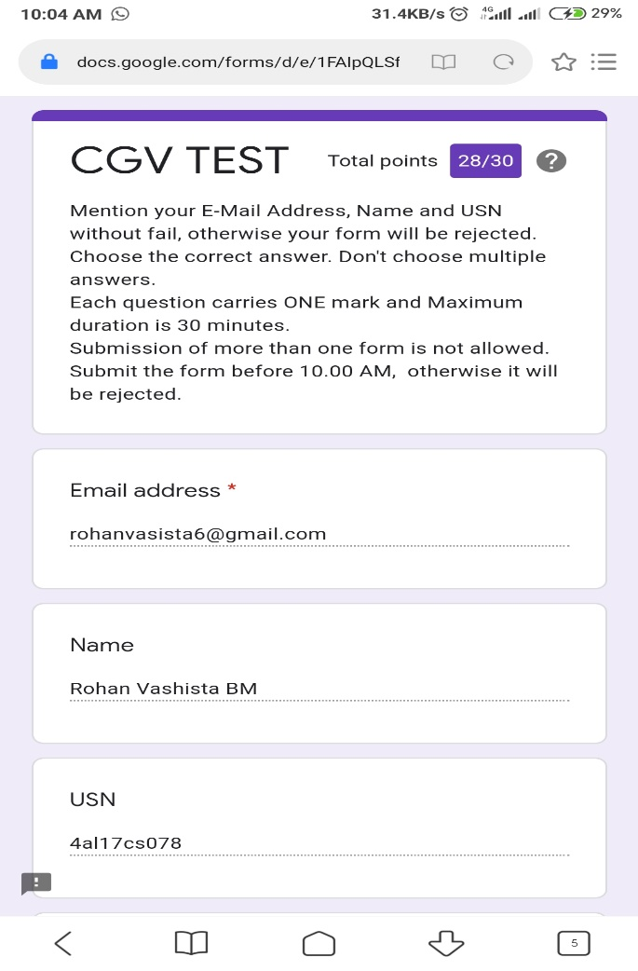

**Raghavi:**

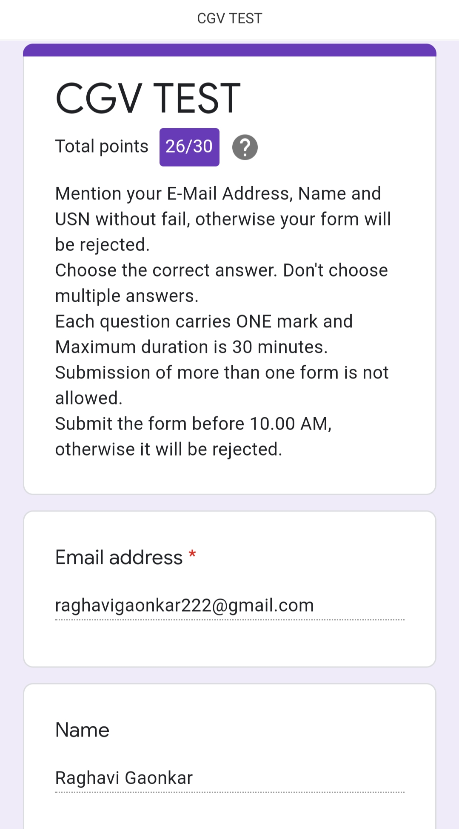

**Rousha:**

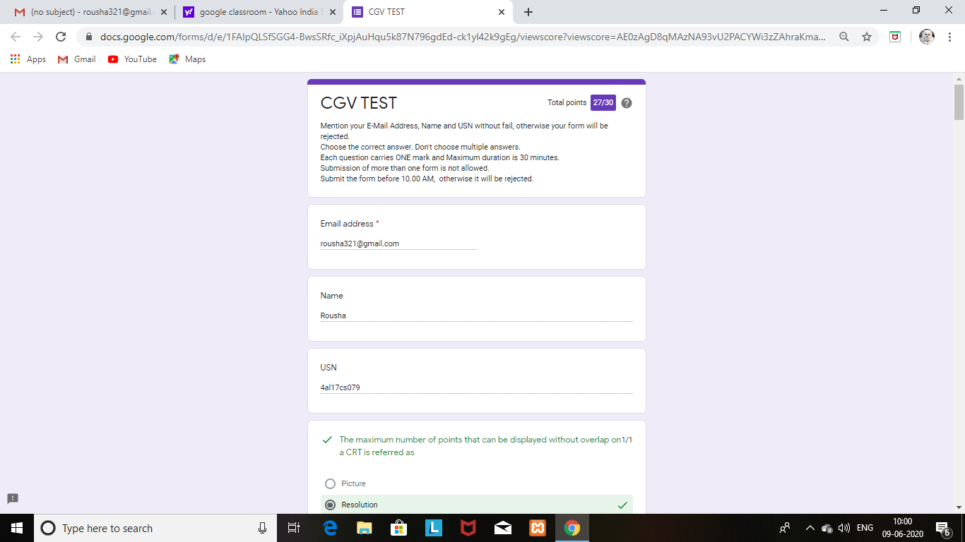

**CRYPTOGRAPHY, NETWORK SECURITY AND CYBER LAWS:**

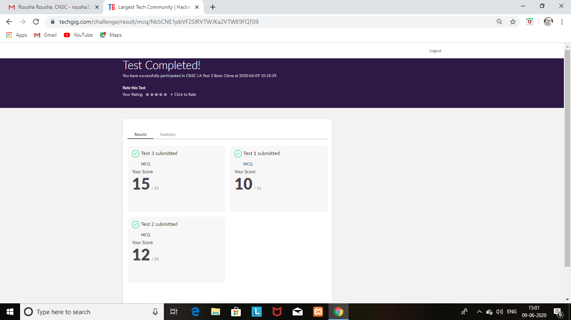

**Shaifa:**

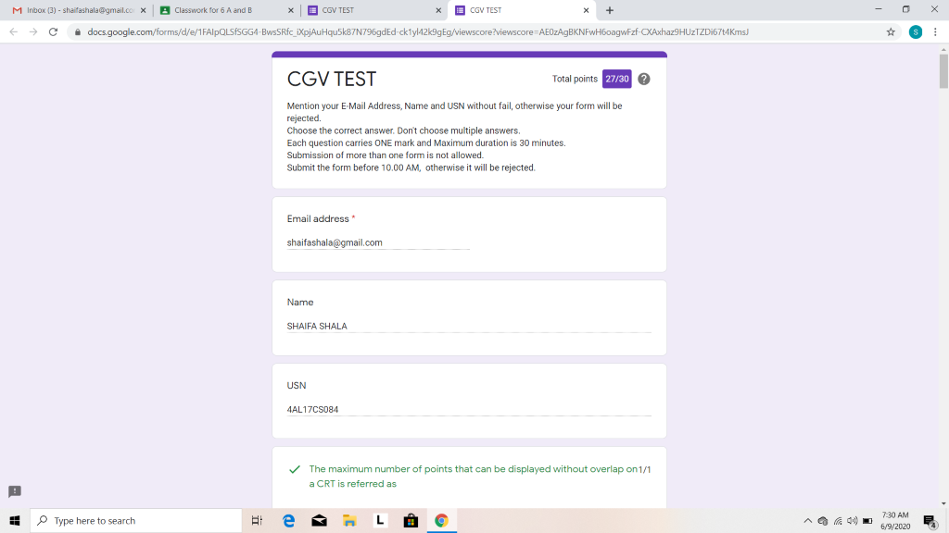

**CRYPTOGRAPHY, NETWORK SECURITY AND CYBER LAWS:**

